Neutron Production Line Quality Monitoring System (NPLQMS) Project Description

Introduction
Singapore Automotive Industries has just opened a large factory in Tuas to produce the Neutron electric car. Designed initially for sale in Singapore this car can travel for up to eight hours on stored battery power or solar power and the battery can also be recharged at places of residence. Small, reliable and cost effective; the manufacturers also believe this vehicle has great export potential, particularly in the crowded city centres in South East Asia. One of the features of the factory in Tuas is that the production line will be completely automated, with the requirement for manual intervention minimised. This production line and the associated support facilities will be controlled by the Neutron Production Line Automated Control System (NPLACS)
The contract for the NPLACS was awarded on 6th January 1997 to Everest Systems Pte Ltd, a Singapore based company with experience in implementing automated control systems in many different locations in South East Asia. The value of this contract is approximately $S10,000,000. The system must be formally handed over on 1 December 1997. As is common with many large projects, the work will be done by Everest Systems and a group of subcontractors who have been selected for their specialist knowledge and experience. They are:
- XpreSS systems Pte Ltd;
- Whitestar computing Pte Ltd;
- WBH systems Pte Ltd.
There are several systems to be constructed, and a representation of the relationships between them is given below.
The major subprojects to be engaged in within this project, and the responsibilities for completing them are described in the table below:
Activity | Overall Responsibility
- Project planning and requirements analysis | Everest
- Systems design | Everest
- Warehouse system implementation | XpreSS
- Production line monitoring & control system implementation | Everest
- Quality monitoring system implementation | WBH
- Production line machine maintenance system | Whitestar
- Production line network system | XpreSS
- Systems integration and acceptance test | Everest
- Initial operation and training | Everest
- Project management | Everest

The Quality monitoring system

Outline
WBH were awarded a subcontract to develop the quality monitoring system for the NPLACS on 6 January 1997. The purpose of this system would be to ensure that the manufactured car meets the most rigorous quality and safety standards. The quality monitoring system was expected to have two major functions:
- On-line quality surveillance subsystem: this system would carry out checks on the cars and on car components on the actual production line itself. The software would control various hardware testing devices, such as ultrasonic scans, electrical testing etc. A prime consideration would be that this system would be independent of, but coordinated with, the production line monitoring and control system. All of this testing would be automatic with no human interaction. It would be a real-time system.
- Defect analysis and correction system: this system would carry out analysis of the collected data and would propose solutions to the defects that had been detected. An intelligent agent would generate these solutions. The user would select the most appropriate solution and the intelligent agent would then implement this solution by sending instructions to the production line machine maintenance system (via the network).
The agreed delivery date is 27 June 1997. If WBH miss this date then the penalty clause may be invoked, which is:
“In the event of late delivery of the system or services, WBH Pte Ltd agrees to pay Everest Systems Pte Ltd 0.1 % of the total contract value by way of recompense for each calendar day past the agreed delivery date. This will continue for ninety days, after which the client may choose to take further sanctions against the contractor, including legal proceedings, without prejudicing these damages.”

Work Plan
Actual work on the project began on 3rd March 1997, as planned. The tasks to be undertaken were as follows:
Task 1 Project Planning
Task 2 Detailed requirements analysis for quality monitoring system
Task 3 Design
Task 3.1 Design of on-line quality surveillance system
Task 3.2 Design of defect analysis and correction system
Task 4 Prototyping
Task 4.1 Prototype on-line quality surveillance system
Note: This subsystem must operate in real–time and hence has difficult performance requirements to meet. Therefore it has been decided to develop a prototype which will:
- Demonstrate that these targets can be met.
- Aid the learning process of writing real-time software.
- Develop code that can be re-used in the actual system.
Task 4.2 Prototype defect analysis and correction system
Note: It was also felt necessary to generate a prototype for this system as this was the first time WBH had been involved in the development of intelligent agents. Accordingly, with the support of a consultant from ISS, NUS this task would:
- Develop a working prototype.
- Test this prototype.
- Develop code that can be re-used in the actual system.
Task 5 Code and Unit Test (CUT)
Task 5.1 Code and unit test of on-line quality surveillance system
Task 5.2 Code and unit test of defect analysis & correction system
Task 6 Integration
Task 7 Systems Test and Performance Test
Task 8 Acceptance Test
Note: this will be performed by Everest Systems as part of the overall Systems Integration and Acceptance activity
Task 9 Project Management
The effort cost and timescale allotted for each task is shown below:
Task | PM | SA1 | SA2 | PR1 | PR2 | PR3 | Con | Total Effort | Task duration
Task 1 Planning | 5 |  |  |  |  |  |  | 5 | 5
Task 2 Requirements | 3 | 10 | 10 |  |  |  |  | 23 | 10
Task 3 Design |  |  |  |  |  |  |  |  | 0
Task 3.1 |  | 10 |  |  |  |  |  | 10 | 10
Task 3.2 |  |  | 10 |  |  |  | 2 | 12 | 10
Task 4 Prototyping |  |  |  |  |  |  |  |  | 0
Task 4.1 |  | 10 |  | 10 |  |  |  | 20 | 10
Task 4.2 |  |  | 10 |  | 10 |  | 5 | 25 | 10
Task 5 CUT |  |  |  |  |  |  |  |  | 0
Task 5.1 |  | 5 |  | 15 |  | 15 |  | 35 | 15
Task 5.2 |  |  | 5 |  | 10 |  | 5 | 20 | 10
Task 6 Integration |  | 5 | 10 |  | 15 | 15 |  | 45 | 15
Task 7: Systems Test |  | 10 | 10 | 10 | 10 | 10 |  | 50 | 10
Task 8 Acceptance | 5 | 5 | 5 | 5 | 5 | 5 |  | 25 | 5
Task 9 Project mgt | 30 |  |  |  |  |  |  | 30 | -
Total | 43 | 55 | 60 | 40 | 50 | 45 | 12 | 305
Cost per day (S$) | 500 | 500 | 500 | 500 | 500 | 500 | 500
Total cost | 21500 | 27500 | 30000 | 20000 | 25000 | 22500 | 6000 | 152500
Key: PM = Project Manager, SA= Systems Analyst, PR = Programmer,
Con = Consultant
The total costs for this subproject are as follows:
Labour cost: 152500
Cost of Hardware: 50000
Cost of Software: 37500
Contingency: 20000
Profit: 40000
PRICE = TOTAL CONTRACT VALUE= 300000
Figure 1 overleaf shows the dependency chart for the tasks, figure 2 shows the Gantt chart and figure 3 shows the project organization.

Figure 1: PERT Chart for Quality Monitoring System Development
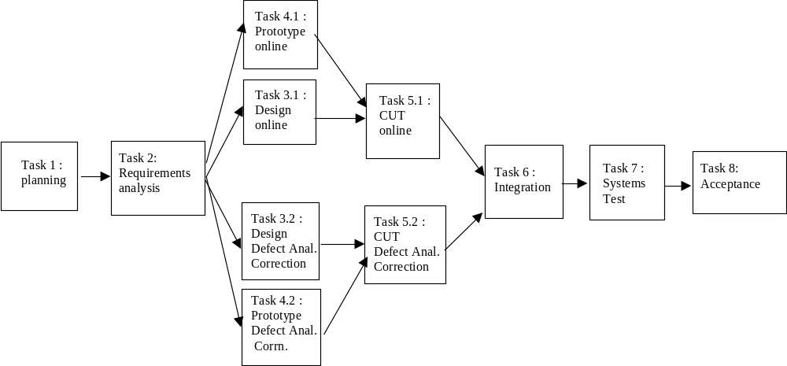

Figure 2: GANT Chart for Quality Monitoring System Development
 |  | 3/3 | 3/10 | 3/17 | 3/24 | 3/31 | 4/7 | 4/14 | 4/21 | 4/28 | 5/5 | 5/12 | 5/19 | 5/26 | 6/2 | 6/9 | 6/16 | 6/23
Task 1 | Planning
Task 2 | Detailed requirements
Task 3.1 | Design of on-line quality
Task 3.2 | Design of def an.al/corrn.
Task 4.1 | Prototype on-line quality
Task 4.2 | Prototype def anal/corrn.
Task 5.1 | CUT on-line quality
Task 5.2 | CUT defect anal/corrn.
Task 6 | Integration
Task 7 | Systems Test
Task 8 | Acceptance Test
Task 9 | Management

Notes: (1) Elapsed time of tasks may not correspond to duration due to constraint on staff availability
(2) One empty week at end of project is “buffer” to absorb any delays within project

Figure 3: Project Organisation
Project
Manager
Consultant

Systems
Analyst 1
Systems
Analyst 2

Programmer
1
Programmer
3
Programmer
2

